Flipkart Mobile Market Assignment - Data Insights

This document presents insights and answers derived from the mobile phone dataset available on Flipkart, visualized using Tableau. The data was analysed to understand pricing segments, brand strategies, and common mobile specifications in the Indian market.

**1. What are the different price range segments for mobiles in India?**

- Low Range: ₹0 – ₹15,000  
- Mid Range: ₹15,001 – ₹30,000  
- Premium Range: ₹30,001 – ₹60,000  
- Flagship Range: ₹60,001 and above  
These segments are defined based on observed price distribution in the dataset.

**2. Which brand provides the most product offerings for the Indian market?**

Based on the dashboard bar chart, the brand with the highest number of models listed is likely Samsung or Apple. This indicates a wide product portfolio covering multiple consumer needs.

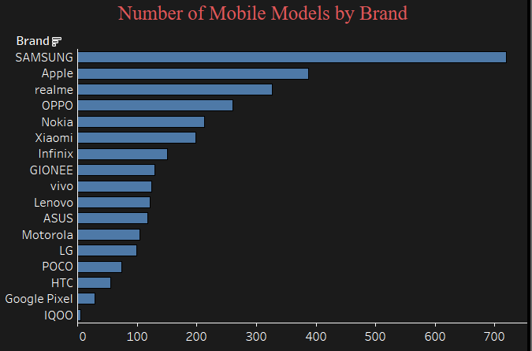

**3. Which brand caters to all different segments? (Low, Mid, Premium)**

Brands like Samsung and Xiaomi appear across all price segments in the stacked bar chart, showing their presence in low-end, mid-range, premium, and flagship categories.

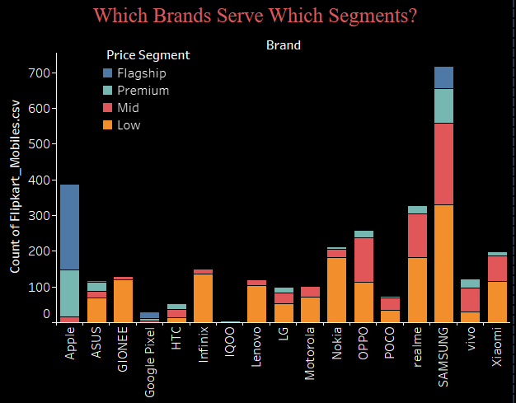

**4. What specifications are the most common that are offered by various brands?**

From the specification bar charts:  
- Most common RAM: 4GB or 6GB  
- Most common Storage: 64GB or 128GB  
These indicate that brands predominantly target the mid-range segment with balanced performance specs.

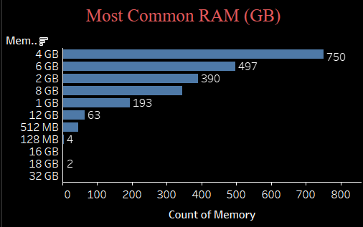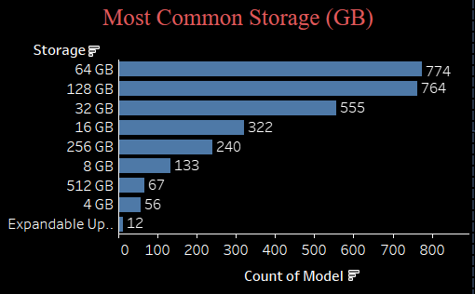

**5. Additional Insights Based on the Dashboard**

- Mid-range mobiles dominate the market, suggesting high consumer interest in the ₹6k–₹25k segment.

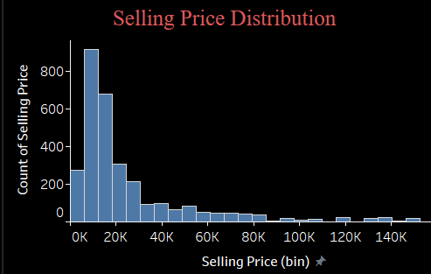

- Brands like Apple and Samsung focus on premium and flagship devices the most.



- A clear correlation is seen between higher RAM/storage and higher price.  
- Filters enable dynamic exploration of specs, price, and brand behavior for different target groups.